# Medicare Observation: A Hospital’s Dilemma

## Abstract and Summary:

Hospital have recently come under much more scrutiny in the face of an ever changing legal/social/political environment. From the start, hospitals have had one crucial standard; to “do no harm.” But living up to such expectations have always come at a price, and in today’s climate, it has become particularly rocky. Specifically, the utilization and management of Inpatient vs. Outpatient has come under increased scrutiny, and new Medicare policy and regulations have created a conundrum for hospitals. Though observations units have been around for years, the creation of new rules has forced hospitals to re-evaluate current admission practices. Inpatient admissions that do not meet the criteria for observation are being denied both concurrently, and through Medicare audits, resulting in hospitals losing valuable revenue. This has caused a rise in observation units being utilized to combat the admissions that are borderline, and to prevent denials. However, staffing and cost of an observation unit is still high, and the benefits have yet to be fully realized.

The objective of this project will be to analyze the pros and cons of an observation unit both from the research literature and from a decision-making process stand-point. CMS has labelled it best, and has given most hospital’s a mantra: "The decision to admit a patient is a complex medical judgment which can be made only after the physician has considered a number of factors, including the patient's medical history and current medical needs, the types of facilities available to inpatients and to outpatients, the hospital's by-laws and admissions policies, and the relative appropriateness of treatment in each setting."7 From this, hospitals from around the US have tried, mostly in vain, to decipher the nature of what a “complex medical” decision, and how it relates to the level of treatment a patient received.5 Our object here will be to analyze the complexity of a few small decisions, for a few small number of diagnosis, to see their impact on patient care.

## Background and Data Collection

The data used is a conglomeration from CMS, NYS Dept. of Health, and a singular hospital in the greater New York area for which I work at. Furthermore, standard comparisons were collected from the research material to gain a better understanding of the observation unit background.

As stated before, observation units have been around for quite some time, however, it was only recently that they became more important to the hospital reimbursement system. As of 2006, CMS created the Recovery Audit Contractor program (RAC), and hired outside entities to review Medicare claims. 4 By doing this, CMS created a program to remove waste from short stay hospital visits, by incentivizing contractors to audit and discover “wrong setting” errors in short-stay inpatient claims.4 In 2008, the RAC program recovered 1.03 billion dollars in Medicare over-payments, a substantial amount.1 As most smaller hospitals and community based hospitals were dependent on fund from Medicare, the additional oversight and audits lead to a decrease in revenue, and lots of hospitals were hit, and some even shut-down. This fear lead to the establishment of observation units to prevent wrongfully setting denials1. The result was an increase in observation units from 19% in the early 2000s, to well over 35% by 2008.4  During this time, hospitals had to learn how to bill appropriately for these admissions in order to maximize revenue.

However, several studies show that the Observation stays have not been as beneficial as they have claimed. In a recent study for observation rates, it has been shown that the net lost per hour for observation is $9.94, compared to the $16.65 gain per hour for an inpatient admission3. And this is a significant lost, as an error in assign a patient to observation rather than inpatient would negatively impact the hospital. We would not be paid for our time, and in fact lose money overall. This is why it is necessary to establish a formula to

For some background, we wanted to compare our exemplar hospital to the national averages. For the Fiscal year 2016 to 2017 there were 92023 ED visits in the year, with 8534 inpatient stays and 1635 observation. Of those inpatient stays, 8395 (98.4%) came from the ED, while 139 (1.6%) came from the observation unit. This data mimics quite closely the national average in 2008, where roughly 1.3% of admissions occurred from the Observation unit4. Comparing the LOS of our observation unit, roughly 65% of our admissions were under 24 hours (average being 22 hours), compared to the national we see only 44% under the 24-hour period. 3

In order to obtain throughput data, and number of visits to the ED, we created the following graphs from our data:

The above graph shows the number of admissions per hour on a 24 hour clock. As you can see, during the early morning hours, the number of visits is very low, will we see a steady increase between the hours of 8 am to noon. This data was used to translate into a rate table for our simulation model, to ensure we have an accurate arrival time for ED visits.

Next we wanted to see how long each was each ED and Obs visit. Again, we created a histogram of the results. First our ED LOS.

Our average length of stay is 10 hours, with most occurring within 24 hour period (I believe New York State regulations are pretty strict about LOS greater than 24 hours). The curious pattern that shows most visits trail off after 16 hours, however, there is an up tick as hour approaches the 24-hour benchmark.

For the observation stays, we shouldn’t see too many values over the 48 hour mark:

Our average length of stay for the observation setting is 22 hours, and we can see a relative consistent distribution around that mean. The data has a tail on the right.

Next we wanted to compare some inpatient Charge data, the below chart highlights our charges by diagnosis as well as the overall charges from the DRG codes taken from the NYS DOH:



It’s interesting to note the discrepancy in the in the All DRG Codes category, particularly in the moderate category. Truth This data was taken from NYS DOH, and the reason for the discrepancy is likely due to some DRG not having a moderate category, and these particular ones are high paying DRGs across all other categories. For our purpose we will be adjusting these DRGs to make a little more sense (ie, an increasing dollar amount from minor to severe).

## Experimentation and Modeling

**Little’s Law Modeling:**

For our experimentation, we first created a simplified model (ED, Obs, and INP Unit), to see the effect of the real-world data vs. a simulation. One of the primary reason’s that most hospital have used Little’s Law as a tool, is its ease and simplicity.2 Using Little’s law, one can condense the whole inpatient and observation cost analysis down to a simple 3 variable formula: average number of patients in system, the length of stay LOS, and the throughput rate.2 Primarily, this was used to calibrate our extensive model to determine if our assumptions could be translated to a more complex system without causing the system to overload.

The overly simplified model that we created for this was: 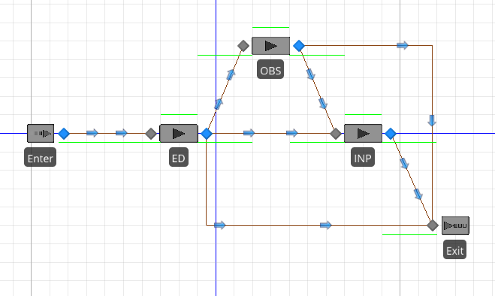

Which shows us an ED, an Observation and an Inpatient server. Each of the paths were weighted to the specified amounts: 1635 observation admissions translates to roughly 2%, while the 8534 inpatient admissions accounted for 9% of the 92023 ED visits. Furthermore, roughly 2% of the observation admissions resulted in an inpatient admission.

Next, we inputted the hospital data. Our facility has 155 inpatient beds, 8 observation beds, and approx. 50 ED beds. Using the interarrival time given above in the data collection section, we found the follow results:

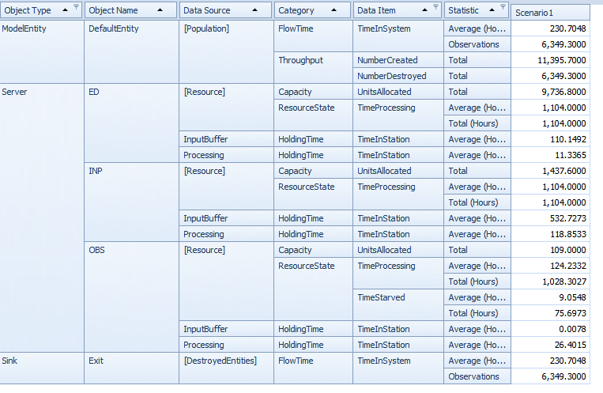

The problem with using the real-world data is that the ED has become impossibly overcrowded, with holding times of upwards of 110 hours. With the real-world data, it goes to show that we can’t possibly account for the additional backlog of patient’s in the ED without adjusting some variables. This explains why the ED usually has a triage area, in order to manage the backlog, and move patients through the ED in a timely fashion.

Even with the over-crowding, we can see how the simplified model did produce data similar to our real-world scenario. Of the total ED visits, 109 were observation, and 1,437 were inpatient which translates to 1% observation, and 12% inpatient visits.

**Criteria-Based Modelling:**

The primary goal of this project was to use criteria based modelling to exam the efficacy of creating specific guidelines for admissions. Our goal was to look at several diagnosis, and compare and contrast theoretical scenarios and criteria. For this process, we decided to implement a more realistic real-world scenario. Once, a patient was given a bed, rather than transferring the patient around to different servers, we had the doctor and the radiologist/labtech, go to the patient’s bed to simulate the desired effects. Furthermore, we added in Delay steps in the processing to simulate processing time for test, and general wait time in the ED rooms. Though this process was tedious, it allowed for greater control and designation of specifics details. Our main criteria for this model was 4 fold, and we selected vitals, diagnostic/radiology test, lab work, and MD exam. Each variable was randomly assigned after the respective resource came and conducted the “test.” For our purposes here, these criteria were arbitrarily set, but if this was a real-world setting, there would be plenty of research and guidelines about the specific conditions that could be utilized to create a more realistic admission.

First, our model looked like this:

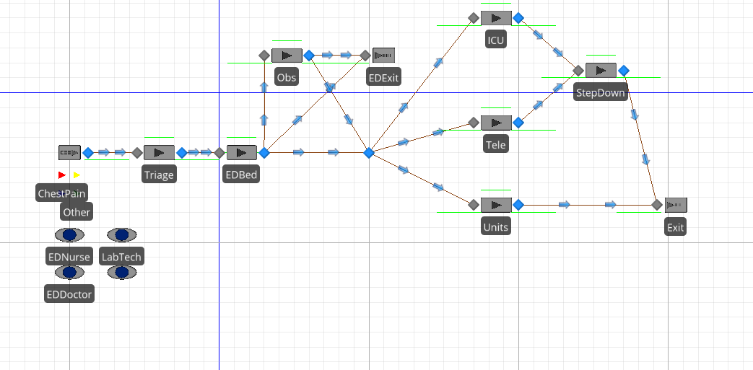

Though not overly complicated, the real work came in the form of the processing of the underlying model. In order to ensure that the model flowed smoothly, we changed the arrival rate of the ED visit from our previous model. We divided the arrival times in half, as a precaution against overcrowding.

As stated earlier, though simple in design, the real work for this model come from the decision making steps that were built in. For this, we designed an extensive ED and OBS process tree:

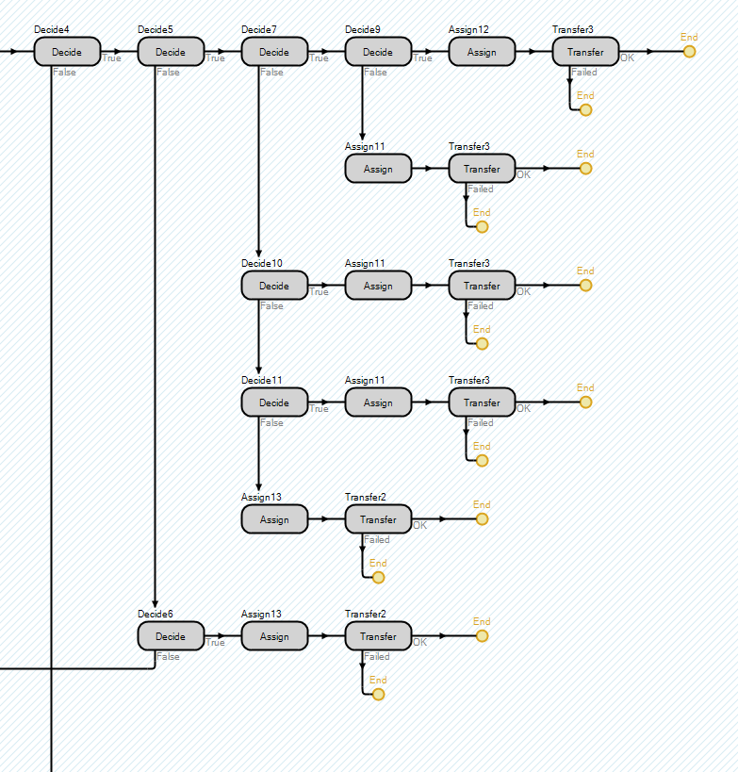

The above step shows the decision making and assignment step from the ED portion of the model. Transfer steps were also utilized to ensure proper pathing and greater control of where the patient was going.

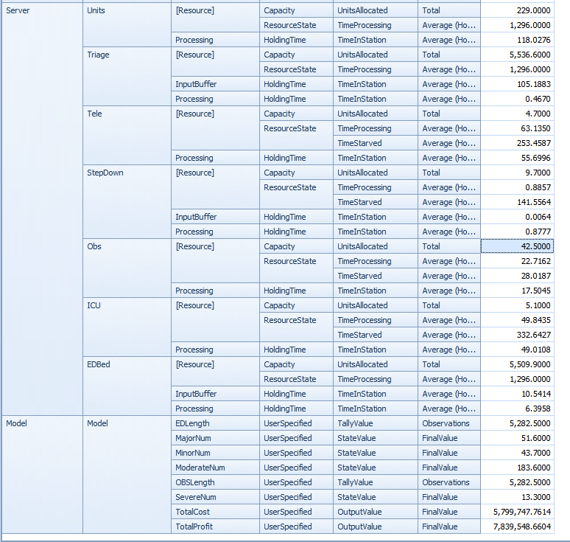

The results obtained above show how our model runs with the imbedded criteria comparing the results to our hospital we can see that approximately 1% of ED visits resulted in an observation level status, and about 5% of the ED visits resulted in observations.

## Conclusion

From our models, we can see that criteria based decision-making is a valid tool to be used when modeling a hospital Observation unit. From the model above, we can see that it is possible to create a series of decision points, both from the doctor and the diagnostic tools, and then using these decision points to determine what level of care is best suited for the patient. In this way, individual hospitals can look at their needs, and find out at what point these decisions need to be made. By breaking down ED visits in to specific criteria, one could approach inpatient admissions in a formulaic manner. In doing this, one could teach and train physician on which features would most likely result in a decrease in short-stay inpatient admissions.

## References:

1 Wiler, J. MD; Ross, R. MD; Ginde, A. MD, 2011, National Study of Emergency Department ObservationServices *Journal of the Society for Academic Emergency Medicine*. <http://onlinelibrary.wiley.com/doi/10.1111/j.1553-2712.2011.01151.x/full>

2 Lovejoy, W. PhD, Desmond, J. MD, 2011, Little’s Law Flow Analysis of Observation Unit Impact and Sizing, *Academic Emergency Medicine*

*http://onlinelibrary.wiley.com/doi/10.1111/j.1553-2712.2010.00969.x/full*

3 Sheehy, A. MD, et al., 2013, Hospitalized but Not Admitted, *JAMA Intern Med.*2013;173(21)

*https://jamanetwork.com/journals/jamainternalmedicine/fullarticle/1710122*

4  Venkatesh AK, Geisler BP, Gibson Chambers JJ, Baugh CW, Bohan JS, et al. (2011) Use of Observation Care in US Emergency Departments, 2001 to 2008. PLoS ONE 6(9): e24326. doi:10.1371/journal.pone.00243265

5 Baugh, C.W., Liang, L., Probst, M.A, Sun, B.C. National Cost Savings From Observation Unit Management of Syncope *Academic Emergency Medicine* 2015;22:934–941

http://onlinelibrary.wiley.com/doi/10.1111/acem.12720/full

6Dataset: Hospital Inpatient Cost Transparency: Beginning 2009. *New York State Dept. of Health*

*https://health.data.ny.gov/Health/Hospital-Inpatient-Cost-Transparency-Beginning-200/7dtz-qxmr/data#revert*

7Centers for Medicare and Medicaid Services, ["Medicare Program; Hospital Inpatient Prospective Payment Systems for Acute Care Hospitals and the Long Term Care Hospital Prospective Payment System and Proposed Fiscal Year 2014 Rates; Quality Reporting Requirements for Specific Providers; Hospital Conditions of Participation; Payment Policies Related to Patient Status,"](http://www.gpo.gov/fdsys/pkg/FR-2013-08-19/pdf/2013-18956.pdf) *Federal Register* 78, no. 160 (2013): 50496-51040.